Handout for sermon on Intimacy with Jesus, July 26.
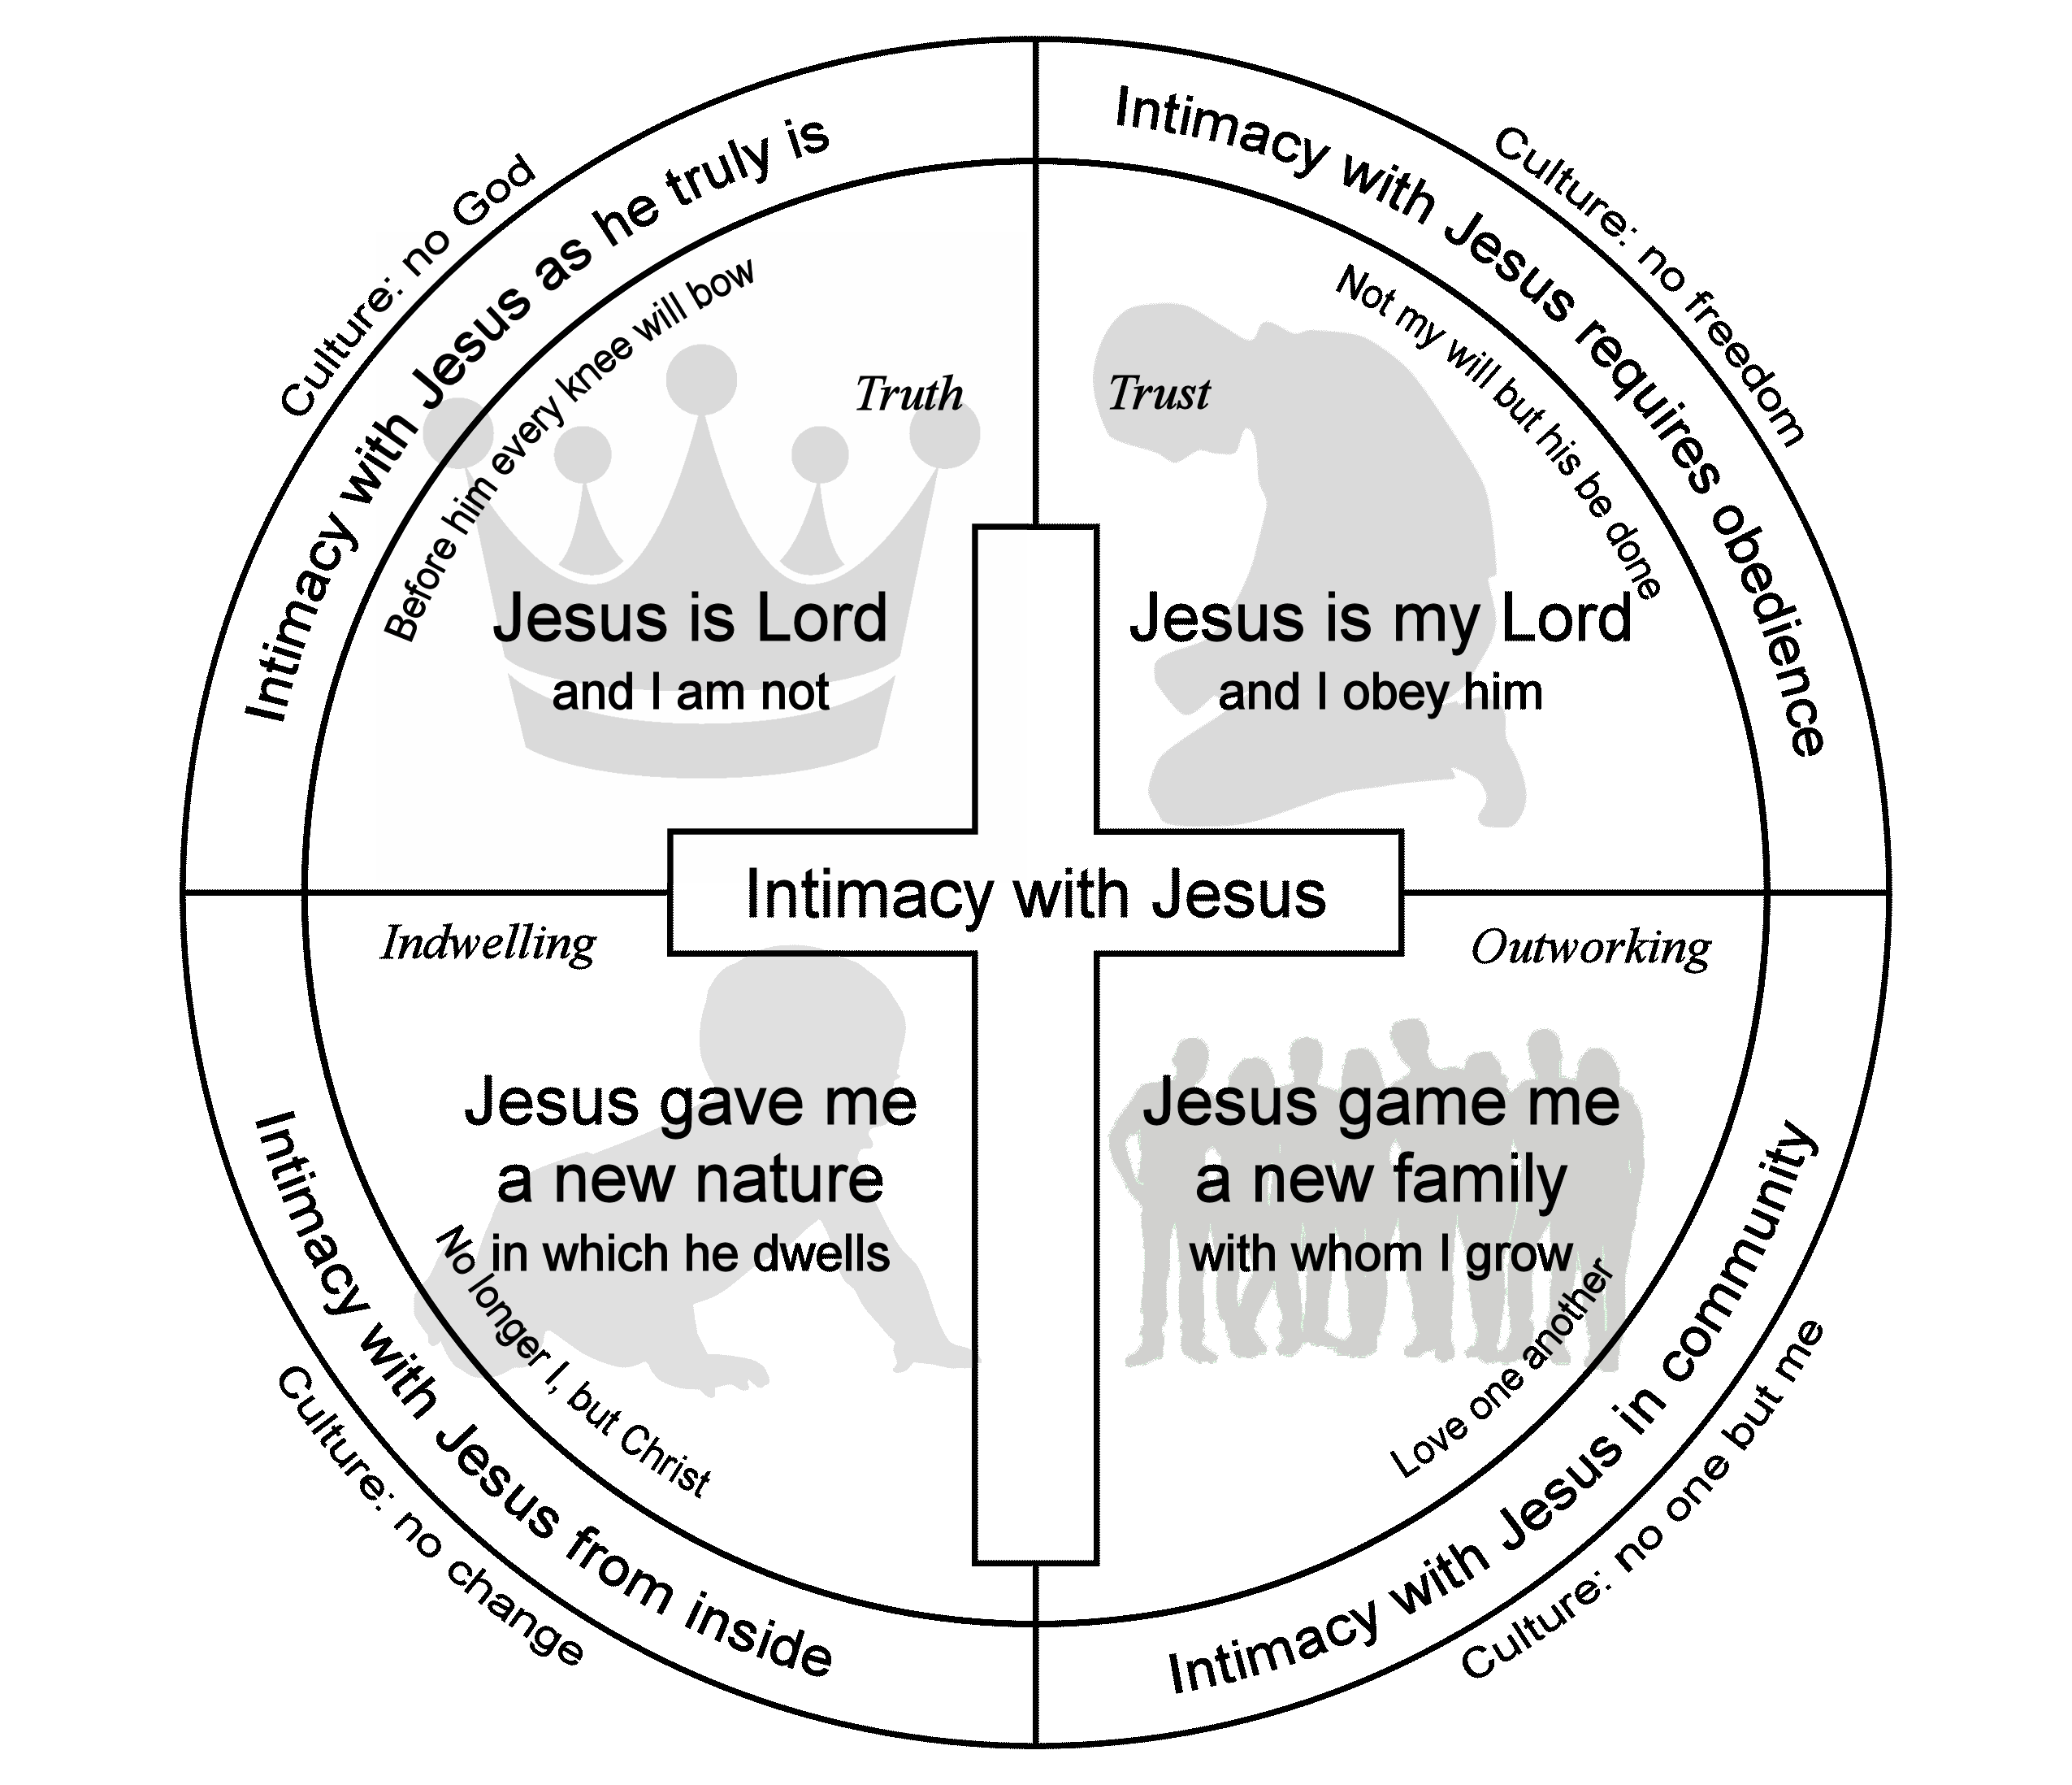
Questions to ponder
- What does it look like for you that Jesus is Lord?
- When is obeying Jesus easy for you? When is it hard? Why?
- What evidence have you noticed that you have been given a new nature?
- When have you seemed to be particularly close to Jesus? When far away?
- What is keeping you for greater intimacy with Jesus? Is it worth it?

Jesus is Lord | Obedience | New nature | New family
Mt 8:27  Mt 11:27  Mt 12:8  Mt 16:16-17  Mt 28:18  Lk 2:11  Jn 5:26-27  Jn 6:68-69  Ac 2:36  Rom 10:9  Eph 1:19-23  Php 2:9-11  Col 1:15-20  Col 2:9-10  Heb 1:2-3  Rev 1:17-18  Rev 11:7  Rev 19;16 | Mt 28:20  Mk 8:34-38  Lk 8:21  Jn 3:36  Jn 14:15,21,23  Jn 15:9-12  Jn 17:2  Rom 1:5  Rom 6:15-18  Rom 12:1  1Cor 1:2  Eph 2:10  Eph 4:1-6  Php 2:12  2Th 1:6-8  2Th 2:15  1Pe 1:2,14-16  1Jn 2:3-6 | Jn 3:3-8  Rom 6:4-14  2Cor 5:17-19  Gal 2:20  Eph 4:22-24  Php 3:7-14  Col 1:27  Col 3:8-11  1Pe 1:3  1Jn 3:6-10  1Jn 5:1-3 | Mk 10:43-45  Jn 13:34-35  Jn 17:20-23  Rom 8:14-17  Rom 12:5  Rom 12:10  Rom 15:5-7  1Cor 13  Gal 5:13  Gal 6:1-2,9-10  Eph 2:14-22  Eph 5:21  Php 2:1-4  1Th 5:14-18  1Pe 1:22  1Jn 3:1

Intimacy with Jesus…
- is abiding in his presence, recognizing his care for us, and actively seeking to follow him in everything.
- is something we experience and not just a theoretical concept.
- involves our hearts and minds, our words and deeds.
- draws us into exalting God and leaves us unconscious of ourselves.
- does not exclude God the Father or God the Spirit. God dwells in us in all persons of the Trinity.
- is not about gaining power for ourselves. It is about him, not us.
- is not a source of pride. All the credit goes to him, not to us.
- can be disrupted by our sin, but it can be restored by repentance and confession.

For further reading see the classics The Practice of the Presence of God by Brother Lawrence or Abide in Christ by Andrew Murray or the more recent The Pursuit of Holiness by Jerry Bridges.
Some for brief thoughts on putting intimacy with Jesus into practice, go to http://www.howardfamily.ca/faith.

